НАЦІОНАЛЬНИЙ ТЕХНІЧНИЙ УНІВЕРСИТЕТ УКРАЇНИ

“КИЇВСЬКИЙ ПОЛІТЕХНІЧНИЙ ІНСТИТУТ

імені ІГОРЯ СІКОРСЬКОГО”

Факультет прикладної математики

Кафедра системного програмування і спеціалізованих комп’ютерних систем

**Лабораторна робота № 3**

з дисципліни:

«Інженерна та комп’ютерна графіка-2. Комп'ютерна графіка»

Виконав: Стецюренко І. С,

Студент групи КВ-03

Перевірив(ла):__________________

Київ-2022

**Тема:** Алгоритми заливки заданих  контурів (областей)

**Мета роботи:** на практичному досвіді ознайомитись із способами заливки довільно заданих контурів (областей) на екрані монітору.

**Постановка задачі:** Програмно реалізувати 4 різні алгоритми заливки (на вибір) довільно заданих областей на екрані монітору.

**Завдання для лабораторної роботи:**

1. Задати області екрану двох видів (многокутник та довільний контур).

2. Заповнити задані області деяким кольором.

3. Порівняти реалізовані алгоритми за швидкодією (на прикладі заповнення одного із контурів) .

**Результат роботи**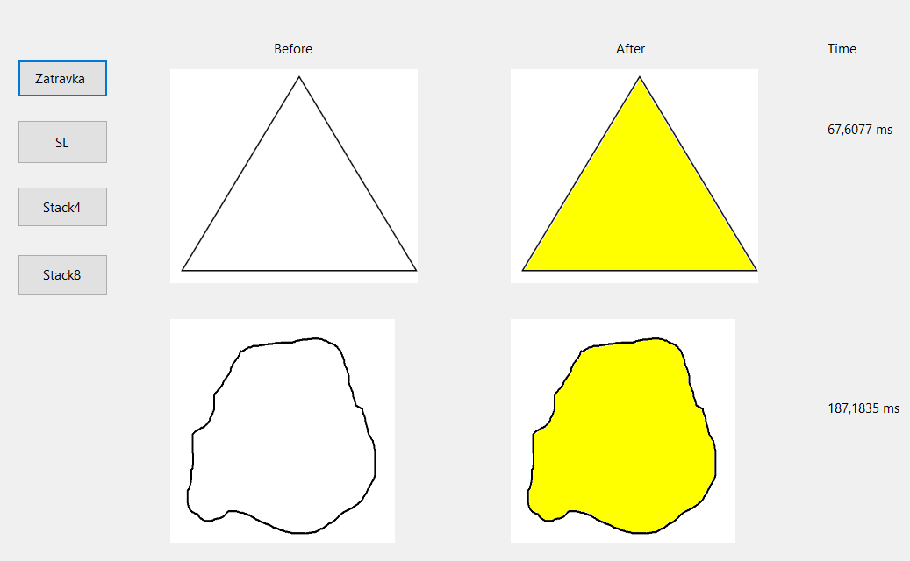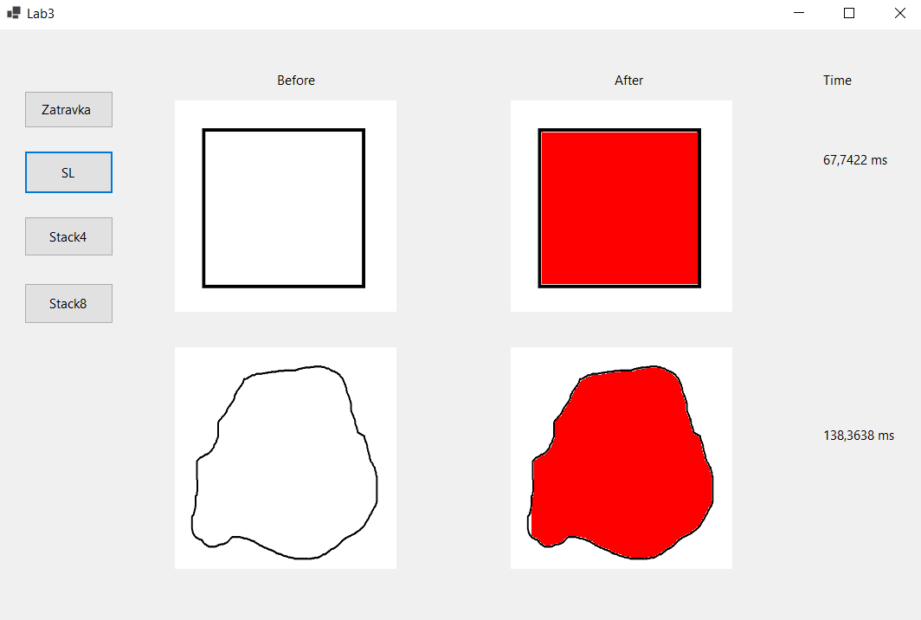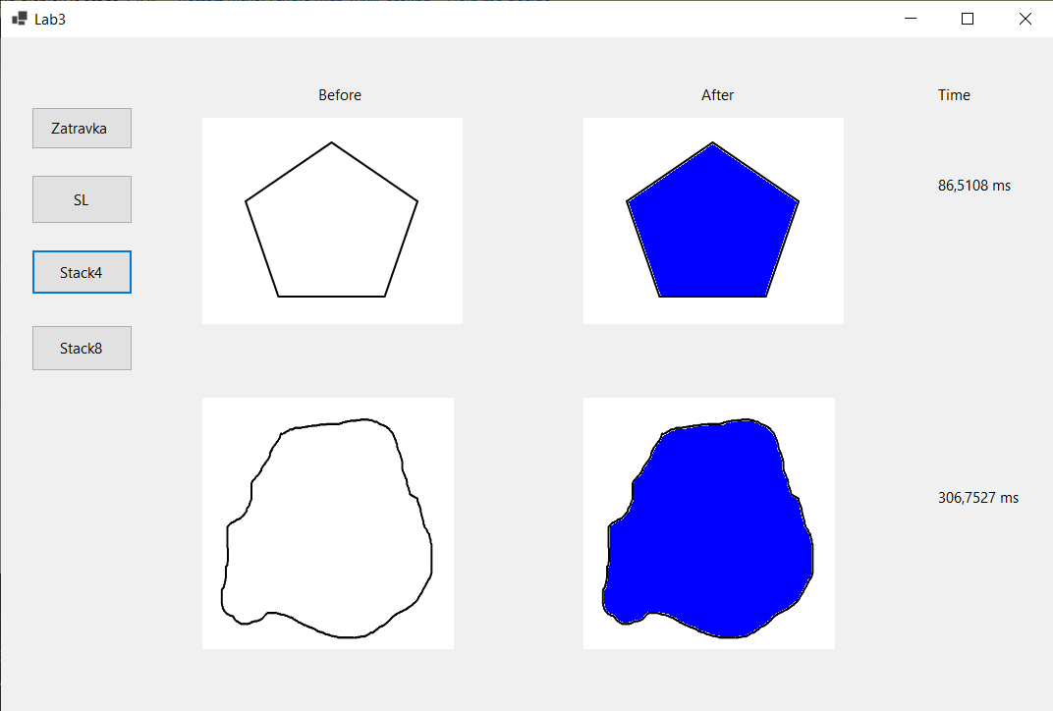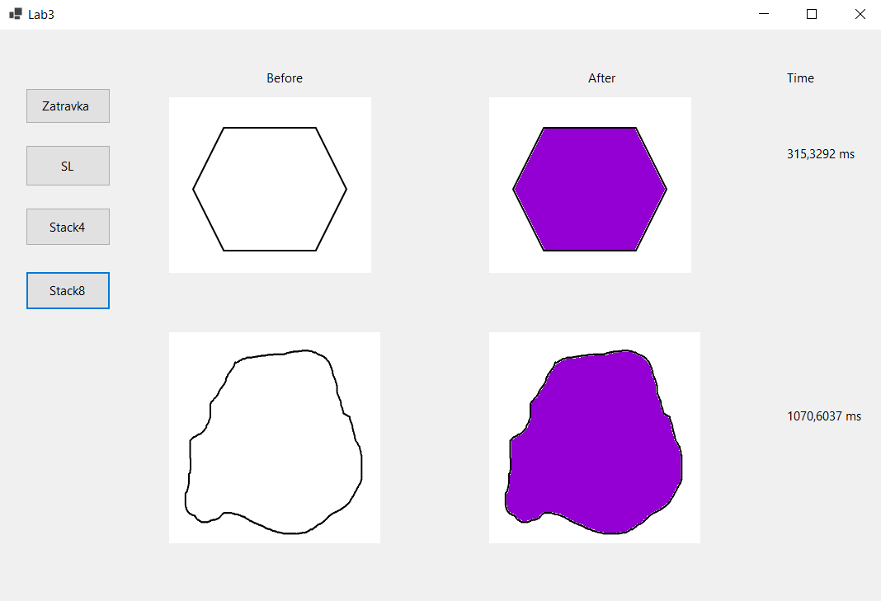

|  |  |  |  |
| --- | --- | --- | --- |
| Алгоритм\Час(мс) | 1 запуск | 2 пуск | 3 пуск |
| Довільний контур | | |
| *Алгоритм заливки із затравкою* | 401 | 393,35 | 411,56 |
| *Алгоритм сканування лінії* | 299,77 | 307,88 | 299,55 |
| *4-сторонній алгоритм на основі стеку* | 694,4 | 703,49 | 715,5 |
| *8-сторонній алгоритм на основі стеку* | 3073,3 | 3089,41 | 3274,98 |

**Код програми**[**(github)**](https://github.com/Stetsiurenko-Illia/ComputerGraphics/tree/main/lab3)

Program.cs

**using** System;

**using** System.Collections.Generic;

**using** System.Linq;

**using** System.Threading.Tasks;

**using** System.Windows.Forms;

**namespace** lab3

{

**static** **class** Program

{

*/// <summary>*

*/// The main entry point for the application.*

*/// </summary>*

[STAThread]

**static** **void** Main()

{

Application.SetHighDpiMode(HighDpiMode.SystemAware);

Application.EnableVisualStyles();

Application.SetCompatibleTextRenderingDefault(**false**);

Application.Run(new Form1());

}

}

}

Form1.cs

**using** System;

**using** System.Collections.Generic;

**using** System.ComponentModel;

**using** System.Data;

**using** System.Drawing;

**using** System.Linq;

**using** System.Text;

**using** System.Threading.Tasks;

**using** System.Windows.Forms;

**using** System.Diagnostics;

**namespace** lab3

{

**public** **partial** **class** Form1 : Form

{

**public** Form1()

{

InitializeComponent();

}

**private** **void** FloodFillzatravka(Bitmap bmp, Point pt, Color replacementColor)

{

Stack<Point> pixels = new Stack<Point>();

Color targetColor = bmp.GetPixel(pt.X, pt.Y);

pixels.Push(pt);

**while** (pixels.Count > 0)

{

Point a = pixels.Pop();

**if** (a.X < bmp.Width && a.X > 0 &&

a.Y < bmp.Height && a.Y > 0)

{

**if** (bmp.GetPixel(a.X, a.Y) == targetColor)

{

bmp.SetPixel(a.X, a.Y, replacementColor);

pixels.Push(new Point(a.X - 1, a.Y));

pixels.Push(new Point(a.X + 1, a.Y));

pixels.Push(new Point(a.X, a.Y - 1));

pixels.Push(new Point(a.X, a.Y + 1));

}

}

}

**return**;

}

**private** **void** FloodFillSL(Bitmap bmp, Point pt, Color replacementColor)

{

Color targetColor = bmp.GetPixel(pt.X, pt.Y);

**if** (targetColor.ToArgb().Equals(replacementColor.ToArgb()))

{

**return**;

}

Stack<Point> pixels = new Stack<Point>();

pixels.Push(pt);

**while** (pixels.Count != 0)

{

Point temp = pixels.Pop();

**int** y1 = temp.Y;

**while** (y1 >= 0 && bmp.GetPixel(temp.X, y1) == targetColor)

{

y1--;

}

y1++;

**bool** spanLeft = **false**;

**bool** spanRight = **false**;

**while** (y1 < bmp.Height && bmp.GetPixel(temp.X, y1) == targetColor)

{

bmp.SetPixel(temp.X, y1, replacementColor);

**if** (!spanLeft && temp.X > 0 && bmp.GetPixel(temp.X - 1, y1) == targetColor)

{

pixels.Push(new Point(temp.X - 1, y1));

spanLeft = **true**;

}

**else** **if** (spanLeft && temp.X - 1 == 0 && bmp.GetPixel(temp.X - 1, y1) != targetColor)

{

spanLeft = **false**;

}

**if** (!spanRight && temp.X < bmp.Width - 1 && bmp.GetPixel(temp.X + 1, y1) == targetColor)

{

pixels.Push(new Point(temp.X + 1, y1));

spanRight = **true**;

}

**else** **if** (spanRight && temp.X < bmp.Width - 1 && bmp.GetPixel(temp.X + 1, y1) != targetColor)

{

spanRight = **false**;

}

y1++;

}

}

}

**private** **void** FloodFill4xStack(Bitmap bmp, Point pt, Color replacementColor)

{

Color targetColor = bmp.GetPixel(pt.X, pt.Y);

Stack<Point> pixels = new Stack<Point>();

pixels.Push(pt);

**if** (targetColor.ToArgb().Equals(replacementColor.ToArgb()))

{

**return**;

}

**int**[] dx = new **int**[] { 0, 1, 0, -1 };

**int**[] dy = new **int**[] { -1, 0, 1, 0 };

**while** (pixels.Count != 0)

{

Point temp = pixels.Pop();

bmp.SetPixel(temp.X, temp.Y, replacementColor);

**for** (**int** i = 0; i < 4; i++)

{

**int** nx = temp.X + dx[i];

**int** ny = temp.Y + dy[i];

**if** (nx >= 0 && nx < bmp.Width && ny >= 0 && ny < bmp.Height && bmp.GetPixel(nx, ny) == targetColor)

{

pt.X = nx;

pt.Y = ny;

pixels.Push(pt);

}

}

}

}

**private** **void** FloodFill8xStack(Bitmap bmp, Point pt, Color replacementColor)

{

Color targetColor = bmp.GetPixel(pt.X, pt.Y);

Stack<Point> pixels = new Stack<Point>();

pixels.Push(pt);

**if** (targetColor.ToArgb().Equals(replacementColor.ToArgb()))

{

**return**;

}

**int**[] dx = new **int**[] { 0, 1, 1, 1, 0, -1, -1, -1 };

**int**[] dy = new **int**[] { -1, -1, 0, 1, 1, 1, 0, -1 };

**while** (pixels.Count != 0)

{

Point temp = pixels.Pop();

bmp.SetPixel(temp.X, temp.Y, replacementColor);

**for** (**int** i = 0; i < 8; i++)

{

**int** nx = temp.X + dx[i];

**int** ny = temp.Y + dy[i];

**if** (nx >= 0 && nx < bmp.Width && ny >= 0 && ny < bmp.Height && bmp.GetPixel(nx, ny) == targetColor)

{

pt.X = nx;

pt.Y = ny;

pixels.Push(pt);

}

}

}

}

**private** **void** button1_Click(**object** sender, EventArgs e)

{

Stopwatch stopWatch = new Stopwatch();

Bitmap bmp1 = new Bitmap(@"D:\KPI\3_course\grafic\lab3\triangl.png");

Bitmap bmp2 = new Bitmap(@"D:\KPI\3_course\grafic\lab3\contour.png");

pictureBox1.Image = new Bitmap(@"D:\KPI\3_course\grafic\lab3\triangl.png");

pictureBox3.Image = new Bitmap(@"D:\KPI\3_course\grafic\lab3\contour.png");

stopWatch.Start();

FloodFillzatravka(bmp1, new Point(128, 128), Color.Yellow);

stopWatch.Stop();

TimeSpan ts1 = stopWatch.Elapsed;

stopWatch.Start();

FloodFillzatravka(bmp2, new Point(128, 128), Color.Yellow);

stopWatch.Stop();

TimeSpan ts2 = stopWatch.Elapsed;

label4.Text = ts1.TotalMilliseconds + " ms";

label5.Text = ts2.TotalMilliseconds + " ms";

label4.Visible = **true**;

label5.Visible = **true**;

bmp1.Save(@"D:\KPI\3_course\grafic\lab3\New.png");

bmp2.Save(@"D:\KPI\3_course\grafic\lab3\NewSecond.png");

pictureBox2.Image = bmp1;

pictureBox4.Image = bmp2;

}

**private** **void** button2_Click(**object** sender, EventArgs e)

{

Stopwatch stopWatch = new Stopwatch();

Bitmap bmp1 = new Bitmap(@"D:\KPI\3_course\grafic\lab3\square.png");

Bitmap bmp2 = new Bitmap(@"D:\KPI\3_course\grafic\lab3\contour.png");

pictureBox1.Image = new Bitmap(@"D:\KPI\3_course\grafic\lab3\square.png");

pictureBox3.Image = new Bitmap(@"D:\KPI\3_course\grafic\lab3\contour.png");

stopWatch.Start();

FloodFillSL(bmp1, new Point(128, 128), Color.Red);

stopWatch.Stop();

TimeSpan ts1 = stopWatch.Elapsed;

stopWatch.Start();

FloodFillSL(bmp2, new Point(128, 128), Color.Red);

stopWatch.Stop();

TimeSpan ts2 = stopWatch.Elapsed;

label4.Text = ts1.TotalMilliseconds + " ms";

label5.Text = ts2.TotalMilliseconds + " ms";

label4.Visible = **true**;

label5.Visible = **true**;

bmp1.Save(@"D:\FormsKG2\MyNew.png");

bmp2.Save(@"D:\FormsKG2\MyNewSecond.png");

pictureBox2.Image = bmp1;

pictureBox4.Image = bmp2;

}

**private** **void** button3_Click(**object** sender, EventArgs e)

{

Stopwatch stopWatch = new Stopwatch();

Bitmap bmp1 = new Bitmap(@"D:\KPI\3_course\grafic\lab3\pentagon.png");

Bitmap bmp2 = new Bitmap(@"D:\KPI\3_course\grafic\lab3\contour.png");

pictureBox1.Image = new Bitmap(@"D:\KPI\3_course\grafic\lab3\pentagon.png");

pictureBox3.Image = new Bitmap(@"D:\KPI\3_course\grafic\lab3\contour.png");

stopWatch.Start();

FloodFill4xStack(bmp1, new Point(128, 128), Color.Blue);

stopWatch.Stop();

TimeSpan ts1 = stopWatch.Elapsed;

stopWatch.Start();

FloodFill4xStack(bmp2, new Point(128, 128), Color.Blue);

stopWatch.Stop();

TimeSpan ts2 = stopWatch.Elapsed;

label4.Text = ts1.TotalMilliseconds + " ms";

label5.Text = ts2.TotalMilliseconds + " ms";

label4.Visible = **true**;

label5.Visible = **true**;

bmp1.Save(@"D:\FormsKG2\MyNew.png");

bmp2.Save(@"D:\FormsKG2\MyNewSecond.png");

pictureBox2.Image = bmp1;

pictureBox4.Image = bmp2;

}

**private** **void** button4_Click(**object** sender, EventArgs e)

{

Stopwatch stopWatch = new Stopwatch();

Bitmap bmp1 = new Bitmap(@"D:\KPI\3_course\grafic\lab3\hexagon.png");

Bitmap bmp2 = new Bitmap(@"D:\KPI\3_course\grafic\lab3\contour.png");

pictureBox1.Image = new Bitmap(@"D:\KPI\3_course\grafic\lab3\hexagon.png");

pictureBox3.Image = new Bitmap(@"D:\KPI\3_course\grafic\lab3\contour.png");

stopWatch.Start();

FloodFill8xStack(bmp1, new Point(128, 128), Color.DarkViolet);

stopWatch.Stop();

TimeSpan ts1 = stopWatch.Elapsed;

stopWatch.Start();

FloodFill8xStack(bmp2, new Point(128, 128), Color.DarkViolet);

stopWatch.Stop();

TimeSpan ts2 = stopWatch.Elapsed;

label4.Text = ts1.TotalMilliseconds + " ms";

label5.Text = ts2.TotalMilliseconds + " ms";

label4.Visible = **true**;

label5.Visible = **true**;

bmp1.Save(@"D:\FormsKG2\MyNew.png");

bmp2.Save(@"D:\FormsKG2\MyNewSecond.png");

pictureBox2.Image = bmp1;

pictureBox4.Image = bmp2;

}

**private** **void** InitializeComponent()

{

**this**.button1 = new System.Windows.Forms.Button();

**this**.button2 = new System.Windows.Forms.Button();

**this**.button3 = new System.Windows.Forms.Button();

**this**.button4 = new System.Windows.Forms.Button();

**this**.pictureBox1 = new System.Windows.Forms.PictureBox();

**this**.pictureBox2 = new System.Windows.Forms.PictureBox();

**this**.pictureBox3 = new System.Windows.Forms.PictureBox();

**this**.pictureBox4 = new System.Windows.Forms.PictureBox();

**this**.label1 = new System.Windows.Forms.Label();

**this**.label2 = new System.Windows.Forms.Label();

**this**.label3 = new System.Windows.Forms.Label();

**this**.label4 = new System.Windows.Forms.Label();

**this**.label5 = new System.Windows.Forms.Label();

((System.ComponentModel.ISupportInitialize)(**this**.pictureBox1)).BeginInit();

((System.ComponentModel.ISupportInitialize)(**this**.pictureBox2)).BeginInit();

((System.ComponentModel.ISupportInitialize)(**this**.pictureBox3)).BeginInit();

((System.ComponentModel.ISupportInitialize)(**this**.pictureBox4)).BeginInit();

**this**.SuspendLayout();

*//*

*// button1*

*//*

**this**.button1.Location = new System.Drawing.Point(31, 71);

**this**.button1.Name = "button1";

**this**.button1.Size = new System.Drawing.Size(103, 43);

**this**.button1.TabIndex = 0;

**this**.button1.Text = "Zatravka ";

**this**.button1.UseVisualStyleBackColor = **true**;

**this**.button1.Click += new System.EventHandler(**this**.button1_Click);

*//*

*// button2*

*//*

**this**.button2.Location = new System.Drawing.Point(31, 140);

**this**.button2.Name = "button2";

**this**.button2.Size = new System.Drawing.Size(103, 50);

**this**.button2.TabIndex = 1;

**this**.button2.Text = "SL";

**this**.button2.UseVisualStyleBackColor = **true**;

**this**.button2.Click += new System.EventHandler(**this**.button2_Click);

*//*

*// button3*

*//*

**this**.button3.Location = new System.Drawing.Point(31, 216);

**this**.button3.Name = "button3";

**this**.button3.Size = new System.Drawing.Size(103, 46);

**this**.button3.TabIndex = 2;

**this**.button3.Text = "Stack4";

**this**.button3.UseVisualStyleBackColor = **true**;

**this**.button3.Click += new System.EventHandler(**this**.button3_Click);

*//*

*// button4*

*//*

**this**.button4.Location = new System.Drawing.Point(31, 293);

**this**.button4.Name = "button4";

**this**.button4.Size = new System.Drawing.Size(103, 47);

**this**.button4.TabIndex = 3;

**this**.button4.Text = "Stack8";

**this**.button4.UseVisualStyleBackColor = **true**;

**this**.button4.Click += new System.EventHandler(**this**.button4_Click);

*//*

*// pictureBox1*

*//*

**this**.pictureBox1.Location = new System.Drawing.Point(205, 82);

**this**.pictureBox1.Name = "pictureBox1";

**this**.pictureBox1.Size = new System.Drawing.Size(282, 244);

**this**.pictureBox1.TabIndex = 4;

**this**.pictureBox1.TabStop = **false**;

*//*

*// pictureBox2*

*//*

**this**.pictureBox2.Location = new System.Drawing.Point(593, 82);

**this**.pictureBox2.Name = "pictureBox2";

**this**.pictureBox2.Size = new System.Drawing.Size(282, 244);

**this**.pictureBox2.TabIndex = 5;

**this**.pictureBox2.TabStop = **false**;

*//*

*// pictureBox3*

*//*

**this**.pictureBox3.Location = new System.Drawing.Point(205, 367);

**this**.pictureBox3.Name = "pictureBox3";

**this**.pictureBox3.Size = new System.Drawing.Size(282, 261);

**this**.pictureBox3.TabIndex = 6;

**this**.pictureBox3.TabStop = **false**;

*//*

*// pictureBox4*

*//*

**this**.pictureBox4.Location = new System.Drawing.Point(593, 367);

**this**.pictureBox4.Name = "pictureBox4";

**this**.pictureBox4.Size = new System.Drawing.Size(282, 261);

**this**.pictureBox4.TabIndex = 7;

**this**.pictureBox4.TabStop = **false**;

*//*

*// label1*

*//*

**this**.label1.AutoSize = **true**;

**this**.label1.Location = new System.Drawing.Point(319, 48);

**this**.label1.Name = "label1";

**this**.label1.Size = new System.Drawing.Size(53, 20);

**this**.label1.TabIndex = 8;

**this**.label1.Text = "Before";

*//*

*// label2*

*//*

**this**.label2.AutoSize = **true**;

**this**.label2.Location = new System.Drawing.Point(709, 48);

**this**.label2.Name = "label2";

**this**.label2.Size = new System.Drawing.Size(42, 20);

**this**.label2.TabIndex = 9;

**this**.label2.Text = "After";

*//*

*// label3*

*//*

**this**.label3.AutoSize = **true**;

**this**.label3.Location = new System.Drawing.Point(950, 48);

**this**.label3.Name = "label3";

**this**.label3.Size = new System.Drawing.Size(42, 20);

**this**.label3.TabIndex = 10;

**this**.label3.Text = "Time";

*//*

*// label4*

*//*

**this**.label4.AutoSize = **true**;

**this**.label4.Location = new System.Drawing.Point(950, 140);

**this**.label4.Name = "label4";

**this**.label4.Size = new System.Drawing.Size(42, 20);

**this**.label4.TabIndex = 11;

**this**.label4.Text = "Time";

*//*

*// label5*

*//*

**this**.label5.AutoSize = **true**;

**this**.label5.Location = new System.Drawing.Point(950, 458);

**this**.label5.Name = "label5";

**this**.label5.Size = new System.Drawing.Size(42, 20);

**this**.label5.TabIndex = 12;

**this**.label5.Text = "Time";

*//*

*// Form1*

*//*

**this**.ClientSize = new System.Drawing.Size(1073, 698);

**this**.Controls.**Add**(**this**.label5);

**this**.Controls.**Add**(**this**.label4);

**this**.Controls.**Add**(**this**.label3);

**this**.Controls.**Add**(**this**.label2);

**this**.Controls.**Add**(**this**.label1);

**this**.Controls.**Add**(**this**.pictureBox4);

**this**.Controls.**Add**(**this**.pictureBox3);

**this**.Controls.**Add**(**this**.pictureBox2);

**this**.Controls.**Add**(**this**.pictureBox1);

**this**.Controls.**Add**(**this**.button4);

**this**.Controls.**Add**(**this**.button3);

**this**.Controls.**Add**(**this**.button2);

**this**.Controls.**Add**(**this**.button1);

**this**.Name = "Form1";

**this**.Text = "Lab3";

((System.ComponentModel.ISupportInitialize)(**this**.pictureBox1)).EndInit();

((System.ComponentModel.ISupportInitialize)(**this**.pictureBox2)).EndInit();

((System.ComponentModel.ISupportInitialize)(**this**.pictureBox3)).EndInit();

((System.ComponentModel.ISupportInitialize)(**this**.pictureBox4)).EndInit();

**this**.ResumeLayout(**false**);

**this**.PerformLayout();

}

}

}

From1.Designer.cs

**namespace** lab3

{

**partial** **class** Form1

{

*/// <summary>*

*/// Required designer variable.*

*/// </summary>*

**private** System.ComponentModel.IContainer components = **null**;

*/// <summary>*

*/// Clean up any resources being used.*

*/// </summary>*

*/// <param name="disposing">true if managed resources should be disposed; otherwise, false.</param>*

**protected** **override** **void** Dispose(**bool** disposing)

{

**if** (disposing && (components != **null**))

{

components.Dispose();

}

**base**.Dispose(disposing);

}

**private** System.Windows.Forms.Button button1;

**private** System.Windows.Forms.Button button2;

**private** System.Windows.Forms.Button button3;

**private** System.Windows.Forms.Button button4;

**private** System.Windows.Forms.PictureBox pictureBox1;

**private** System.Windows.Forms.PictureBox pictureBox2;

**private** System.Windows.Forms.PictureBox pictureBox3;

**private** System.Windows.Forms.PictureBox pictureBox4;

**private** System.Windows.Forms.Label label1;

**private** System.Windows.Forms.Label label2;

**private** System.Windows.Forms.Label label3;

**private** System.Windows.Forms.Label label4;

**private** System.Windows.Forms.Label label5;

}

}